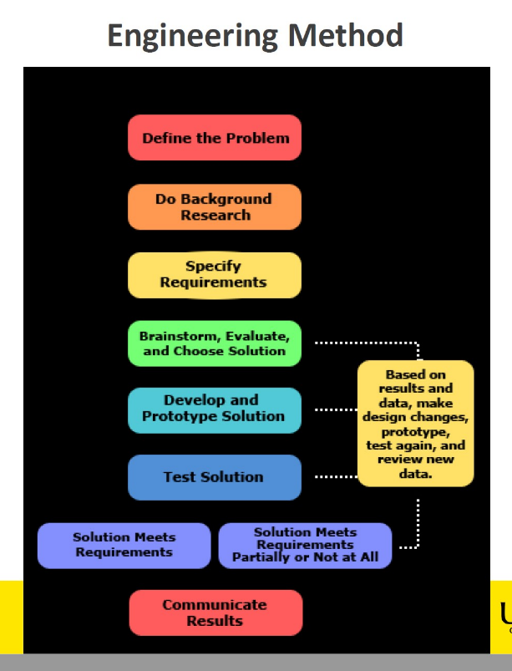**Where I am at now?**

* Currently in the “Define the problem” stage
* Moving into the Background research stage to provide substance for the claims in the defining the problem stage
* Looking at defining some requirements (within the context of completing the thesis) that will guide the future direction of the project

The project has evolved now from looking at improvements in the primary UHF radio for TT&C of a nano satellite to looking at a back-up TT&C radio that is independent of all other sub-systems in the satellite. The main driver in prompting the change is that there is already a magnitude of radios available that suit the purpose of providing the primary TT&C and during discussions of improvements it was suggested for an alternative back-up/emergency for TT&C comms. I will investigate a design solution that will provide (in order of importance)…

1. Provide a low power radio source that provides tracking data that is sourced independently from the satellite mission system, powered independently from the satellite power system and is independent from any deployment mechanism of the satellite (antenna arms, solar panels etc.)
2. Provide telemetry data that is independent of the satellite mission systems to serve an alternative fault-finding tool
3. Possible extension, provide an alternate path for mission or TT&C system rebooting
4. Provide a satellite identification system (similar to aircraft IFF or shipping AIS) to help with space situational awareness.
5. Develop a world-wide, open source satellite tracking system to provide a similar function like flight-radar/flight-tracker

**Define the problem**

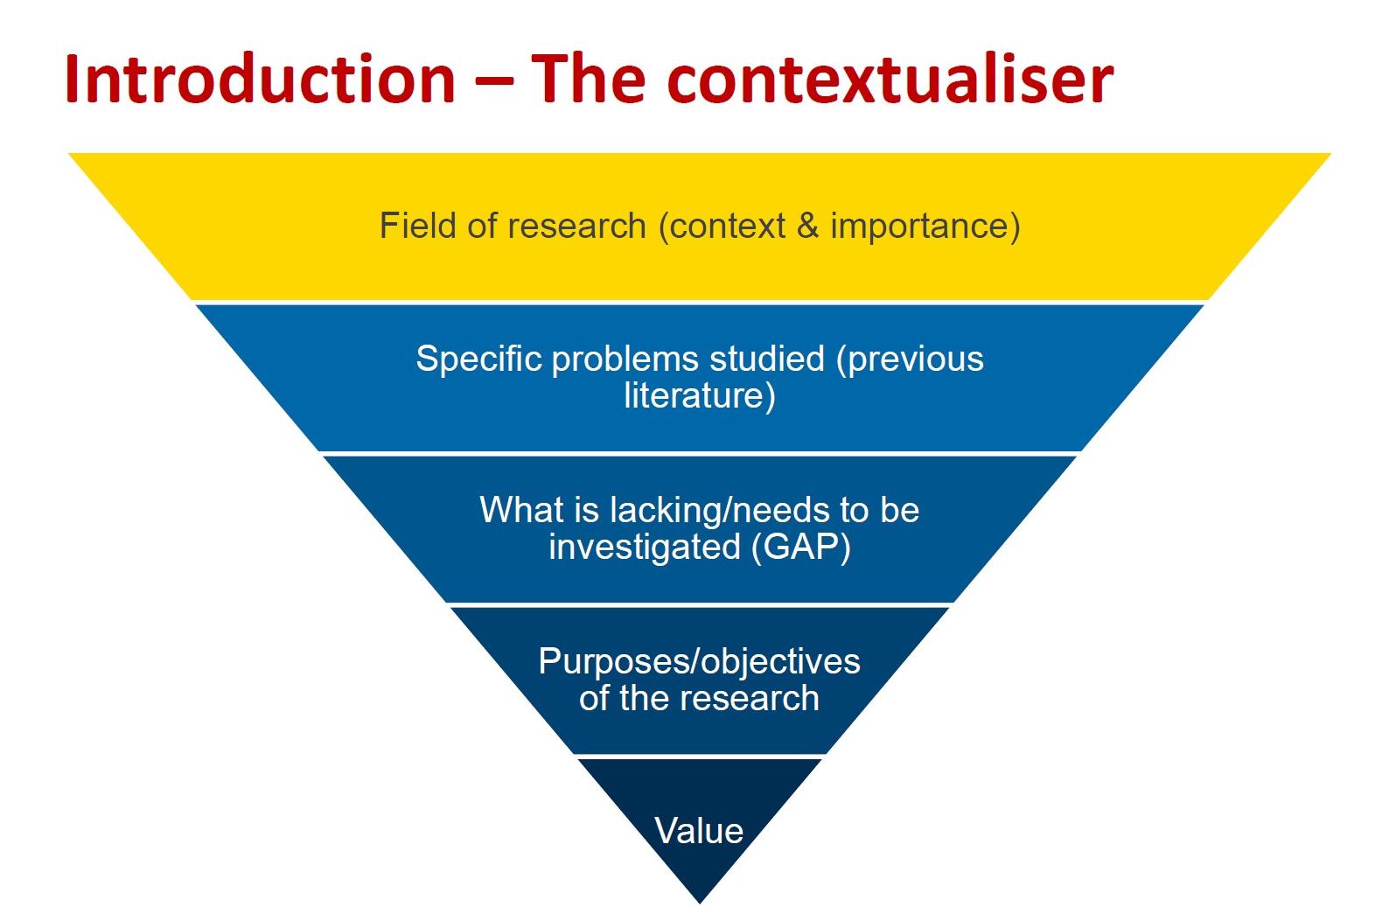

**Field of Research (Context & importance)**

The lower cost of manufacture and delivery of small-sized satellite (<100kg) has led to an increasing number of satellites in low earth orbit (<2000km) *ref 1&2 below. The Dead-On-Arrival rates for small satellites are approx. 25-30% (references to be found) with the main causes being difficult to accurately determine.

1. In the 1–50 kg range alone, there were fewer than 15 satellites launched annually in 2000 to 2005, 34 in 2006, then fewer than 30 launches annually during 2007 to 2011. This rose to 34 launched in 2012, and 92 launched in 2013.[[2]](https://en.wikipedia.org/wiki/Small_satellite#cite_note-swma2014-2)

[https://web.archive.org/web/20140222211907/http://www.sei.aero/eng/papers/uploads/archive/SpaceWorks_Nano_Microsatellite_Market_Assessment_January_2014.pdf](https://web.archive.org/web/20140222211907/http:/www.sei.aero/eng/papers/uploads/archive/SpaceWorks_Nano_Microsatellite_Market_Assessment_January_2014.pdf)

2. European analyst Euroconsult projects more than 500 smallsats being launched in the years 2015–2019 with a market value estimated at US$7.4 billion.[[3]](https://en.wikipedia.org/wiki/Small_satellite#cite_note-pa20150302-3)

<http://www.parabolicarc.com/2015/03/02/euroconsult-sees-large-market-smallsats/>

**Specific problems studied (Previous literature)**

The inability to identify or communicate with small satellites and the difficulty of tracking by optics or c-band radar results in an increased risk in collisions which will increase exponentially with an increase satellites (references to be found). Need to determine why space situational awareness is important, why collisions are bad etc.

**What is lacking/needs to be investigated**

An alternative communication method that is independent of the rest of the satellite system to provide base communications with a ground state that can provide information/data in case of emergency (DOA satellite situation).

**Purposes/Objectives of the research**

To investigate producing an emergency radio subsystem that is independent of all other satellite sub-systems that utilises/redesigning/repurposing existing radio or circuit components designs. Looking at alternative purposes that the emergency radio can be used for including the design of a universal satellite identification system.

**Value**

* Improve the reliability of the communications system with small satellites
* Provide an alternate method of communication to assist fault-finding of DOA situations
* Increased space situational awareness for small satellites within the LEO area